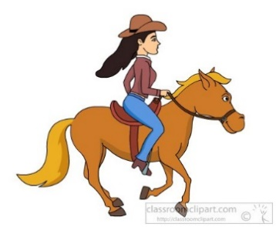
BUILDING RESILIENCY THROUGH
HORSEMANSHIP (YOUTH CLASS)
Join us at our scenic ranch for 3 days of fun-filled activities!!! Learn horse behaviors, safety around horses, equipment used, grooming, and proper care for horses. As well as how to lead and work with horses on the ground and basic riding skills. You will be able to take the lessons learned and apply them in everyday life. Additional activities include interaction with other farm animals, arts, crafts, and outdoor fun. Play with our first “kids” (baby goats due early June).
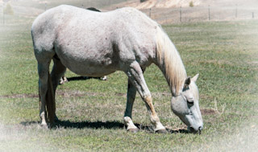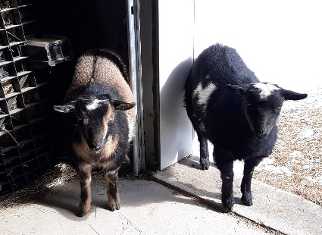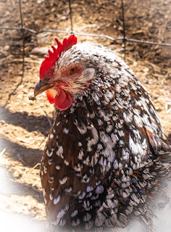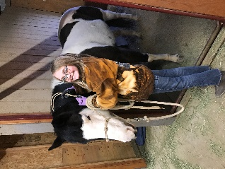
Certified Horsemanship Association (CHA) and PATH certified instructors
DATES:
14-16 June 2021 8:00am – 12:30pm (Bring Sack Lunch) Age group 9-13
19-21 July 2021 8:00am – 12:30pm (Bring Sack Lunch) Age group 9-13
2-4 August 2021 8:00am – 12:30pm (Bring Sack Lunch) Age group 13-17

Cost: $285 CASA: Milton Fund

Where: Holistic Therapeutic Equine Center
@ Split Pine Ranch
15385 Black Forest Road, Colorado Springs, CO
Additional Information, reservation applications Call Cindy @ 719-337-4496

