SNAP Outreach for Schools: Sample Language and Graphic
for School District Communication Channels
Use in newsletters, emails, website, or other communications.

Apply at myBenefits Graphic
- Right-click the image to save it to your computer
- Link to NY State’s MyBenefits online portal, where families can apply for SNAP.
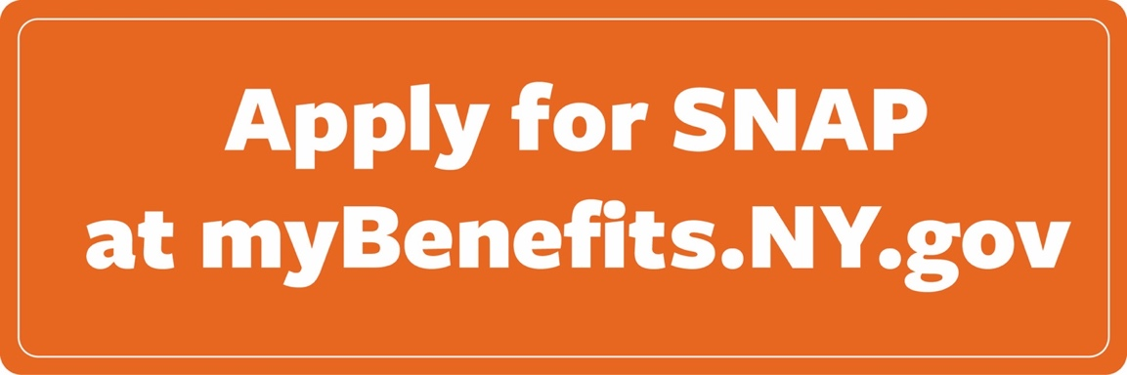
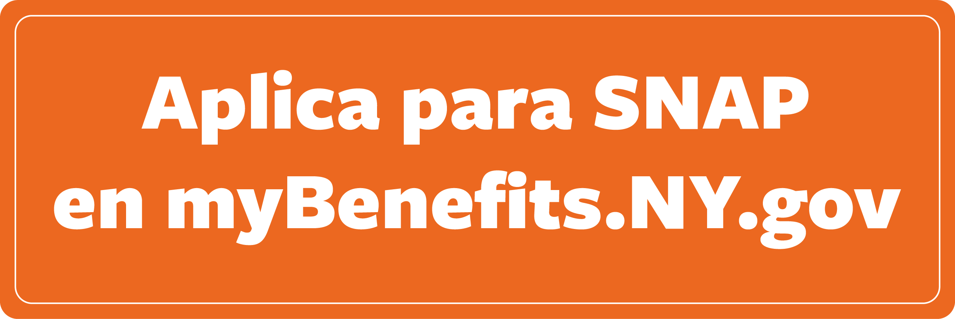

Sample Language for Communications
Blurb to describe SNAP and encourage families to apply:
With grocery prices on the rise, many families need extra help to get enough to eat. SNAP is a monthly benefit to buy food at grocery stores and farmers markets and helps stretch your food budget. Find out if you may be eligible and apply at MyBenefits.ny.gov. Have questions or need help applying? Visit FoodHelpNY.org to find free and confidential assistance.
Con los precios de los comestibles en aumento, muchas familias necesitan ayuda adicional para obtener suficiente para comer. SNAP es un beneficio mensual para comprar alimentos en supermercados y mercados de agricultores y ayuda a estirar su presupuesto de alimentos. Averigüe si puede ser elegible y solicite en MyBenefits.ny.gov. ¿Tiene preguntas o necesita ayuda para presentar una solicitud? Visite FoodHelpNY.org para encontrar asistencia gratuita y confidencial.

