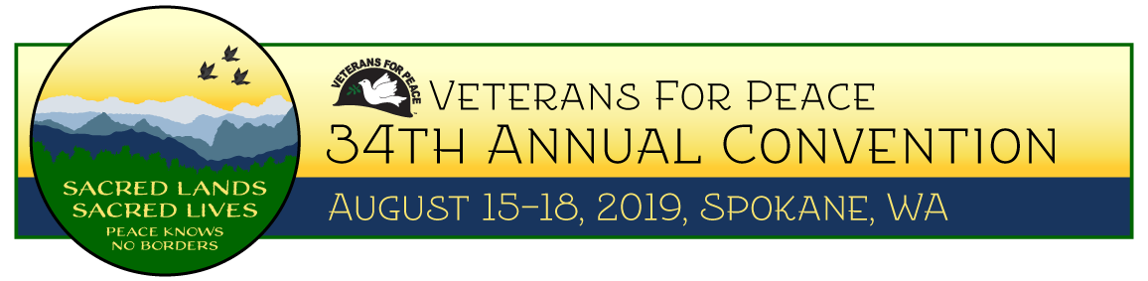

Workshops are one of the most important activities during the Veterans For Peace annual conventions. Most of them are organized and led by Veteran For Peace members. We greatly appreciate the time and effort presenters put into creating their workshops.

Usually there are two days of workshops. This year there is only one day, Friday, August 16, therefore time slots are more limited than in past years. As a result, not all workshops will be selected.

Workshops that follow the theme of the convention, Sacred Lands, Sacred Lives: Peace Knows No Borders, and/or address these issues—

- Climate Change and Militarism/The Environmental Cost of War
- U.S. Intervention Around the Globe

—will receive high preference but are not guaranteed acceptance.

If we receive two or more proposals on the same or similar topics, we may ask you to combine your workshop with another presenter.

Convention registration for presenters: All workshop presenters are required to register for the convention. Workshop presenters do not receive free registration. However, on the registration form, workshop presenters are given the option to register at the reduced rate.

If you have questions regarding registration fees, please contact Shelly at 314-725-6005 or email her at shelly@veteransforpeace.org.

Application deadline: May 31, 2019. A confirmation email will be sent upon receipt of electronic proposal submissions. Anyone submitting a proposal will be notified as to acceptance by June 30.
Email application and questions to: workshop_proposals@veteransforpeace.org
or

Snail mail to: Attn: Workshop Proposals
Veterans For Peace
1404 N. Broadway
Saint Louis, MO 63102

Name:
Mailing Address:
City, State & Zip:
Phone: Email:
Organization Name or Chapter Number:

Type of presentation: Please check all applicable.
Lecture_____ Open Discussion_____ PowerPoint or Film_____ Panel Presentation_____
Participatory (hands-on activities) _____ Other______________________________________

Title of workshop:

Name(s) and brief biography of presenter(s):

Social media handles of presenter(s) and/or organizations affiliated with presentation:

Brief description of workshop (150 words or less): Please use back of application or 2nd page.

Workshop aids requested:
Projector_____
Microphone (s) If more than one, state number required______
Projection screen_____
Flip chart(s) If more than one, state number desired_____
Erasable Board (s) If more than one, state number desired_____

All workshops will be Friday, August 16, 2019.

Would you be willing to collaborate with another presenter with similar topic? Yes___ No___

Additional info:

