Rural Counts: NC Small Business Legislative Update (Sept. 21’)
The North Carolina General Assembly continues to work towards a budget for FYS 2021-2023. Currently, internal negotiations are taking place between the Legislature and the Governor to hopefully reach a compromise on key issues such as Medicaid Expansion, tax cuts, state employee raises, and more.
If Governor Cooper signs this budget, it would be the first and last omnibus bill of his gubernatorial tenures. Without his signature, the bill heads back to the legislature for a veto override vote. To pass, the bill would need 3/5 of the House and Senate to vote in favor of the legislation, meaning at least two Democrats in the Senate and three in the House would need to join Republicans in a fully attended vote in both Chambers. If a vote to override the budget were to fail, “mini budgets” (smaller bills containing small portions of the larger omnibus budget) would then be considered, .
The Rural Center is advocating for provisions included in the House and Senate budget proposals that will make significant investments in small business development, broadband, health, housing, and water and wastewater systems. See below for a detailed comparison of each chamber's budget proposals as it relates to several policy proposals that impact rural communities.
Senate vs House 2021-2023 FYS Budget Proposal Comparison
SENATE | HOUSE
Invest in Stronger Entrepreneurship and Small Business Development System
(these provisions relate to the recommendations found in the NC Rural Center’s North Carolina’s New Small Business Plan)
State Small Business Credit Initiative: $120.5 million for the State Small Business Credit  Initiative (SSBCI), a program managed by the NC Rural Center that works with lending institutions to increase their own lending capacity and provide more direct loans to small businesses in local communities throughout the state. | State Small Business Credit Initiative: $120.5 million for the State Small Business Credit  Initiative (SSBCI), a program managed by the NC Rural Center that works with lending institutions to increase their own lending capacity and provide more direct loans to small businesses in local communities throughout the state.
One North Carolina Small Business program: $2 million each year to matching and incentive grant programs to small businesses applying for  and leveraging federal Small Business Innovative Research (SPIR) and Small Business Technology Transfer (STTR) programs. | One North Carolina Small Business program: $7 million nonrecurring in 2021-2022 and an additional $2 million recurring each year to matching and incentive grant programs to small businesses applying for and leveraging federal Small Business Innovative Research (SPIR) and Small Business Technology Transfer (STTR) programs.

Community Development Financial Institutions (CDFI): $5 million directly to the Rural Center for capacity-building grants. | Not included
Small Business Centers: No changes in funding | Small Business Centers: No changes in funding
Historically Underutilized Businesses (HUB)  Office: No change in funding | Historically Underutilized Businesses (HUB)  Office: No change in funding
ReToolNC Grants Programs: $20 million for additional grants for small, historically underutilized businesses. | ReToolNC Grants Programs: $20 million for additional grants for small, historically underutilized businesses.
Shellfish grower loan program: $500k each year to the Shellfish Growers Loan Program, a new loan program managed by the NC Rural Center to grow small shellfish farmer access to working capital. | Not included
Small Business Pandemic Recovery Grant Program: $500 million for rural businesses that suffered economic damage but did not receive other pandemic funding such as PPP and other grants. | Generating Recovery for Organizations Without Earlier Relief Grant Program (GROWER): $500 million for the GROWER Grant Program to aid  businesses in the State that suffered substantial  economic damage from the COVID-19 pandemic (Does allow some grant amount for eligible businesses that received other assistance such as PPP and other grants).
Rural Downtown Transformation Grants: $50 million for local governments in Tier 1 and Tier 2 counties. | Rural Downtown Transformation Grants: $50 million for local governments in Tier 1 and Tier 2 counties.
Not included | Contractor Business Academy for HUBs: $3 million to the Carolina Associated General  Contractor’s Foundation (CAGC Foundation), Inc. to conduct a construction contractor business academy for historically underutilized businesses.
Not included | Rural Tourism Recovery: $1.5 million for the Department of Commerce for its contract with the Economic Development Partnership of North Carolina (EDPNC) for rural tourism recovery.

NCGA 2021 Long Session – Small Business Legislation.
Below are highlights of a few of the many small business focused legislation that have been introduced this legislative session.

- S228 - Allow Employers to Offer EPO Benefit Plans, Allows insurers to offer exclusive provider benefit health plans. These plans would only offer out-of-network coverage for emergency services and for medically necessary services in situations when an in-network provider was not reasonably available. This bill was signed into law on September 10.

- H969 - Small Business Truth in Financing, requires nonbank commercial lenders to provide disclosures of the financing costs of their products to allow small business owners to make informed comparisons between financing options. The bill was referred to the House Commerce committee on May 12.

- H624: North Carolina Regulatory Sandbox Act, waives certain regulations so that financial tech innovations can be tested in the marketplace for a limited time. The intention is to bring products to the market faster while preserving consumer protections. This bill was signed into law on October 15.

- H680: Reenact Qualified Business Venture Credit, reinstates tax credit for people who invest in certain qualified business ventures—including those engaged primarily in manufacturing, processing, warehousing, wholesaling, research and development, service-related, or commercialization of IT—that has a gross revenue of up to $5 million, qualified grantee businesses, and qualified licensee businesses. The bill also increases the tax credit by 10 percent for investments made in opportunity zones or Tier 1 or 2 counties. The bill was referred to the House Finance Committee on July 20.
- S493 - JDIG Multilocation Projects Modifications, increases the annual Job Development Investment Grant (JDIG) for any business headquarters relocating in the state by 20 percent if the business meets certain requirements, such as relocating its out-of-state manufacturing operation to a development Tier 1 or Tier 2 area. The bill’s intention is to incentivize certain businesses to create full time jobs in the state. The bill passed the Senate (49-0) on April 27 and was sent to the House on April 28. The bill was referred to the House Rules Committee on June 24.
- H899: North Carolina Work and Save, would establish a Small Business Retirement Savings Program and would create the North Carolina Small Business Retirement Board. This board would design and administer payroll deduction retirement savings programs in partnership with private sector entities, to be offered to employers that do not maintain tax-qualified retirement plans for their employees. The bill was voted favorably out of the House Commerce Committee with a substitute and re-referred to the House Appropriations Committee on June 22.
  - Note: Included in House Budget Proposal ($400,000 NR for FY 2021-22 and FY 2022-23)
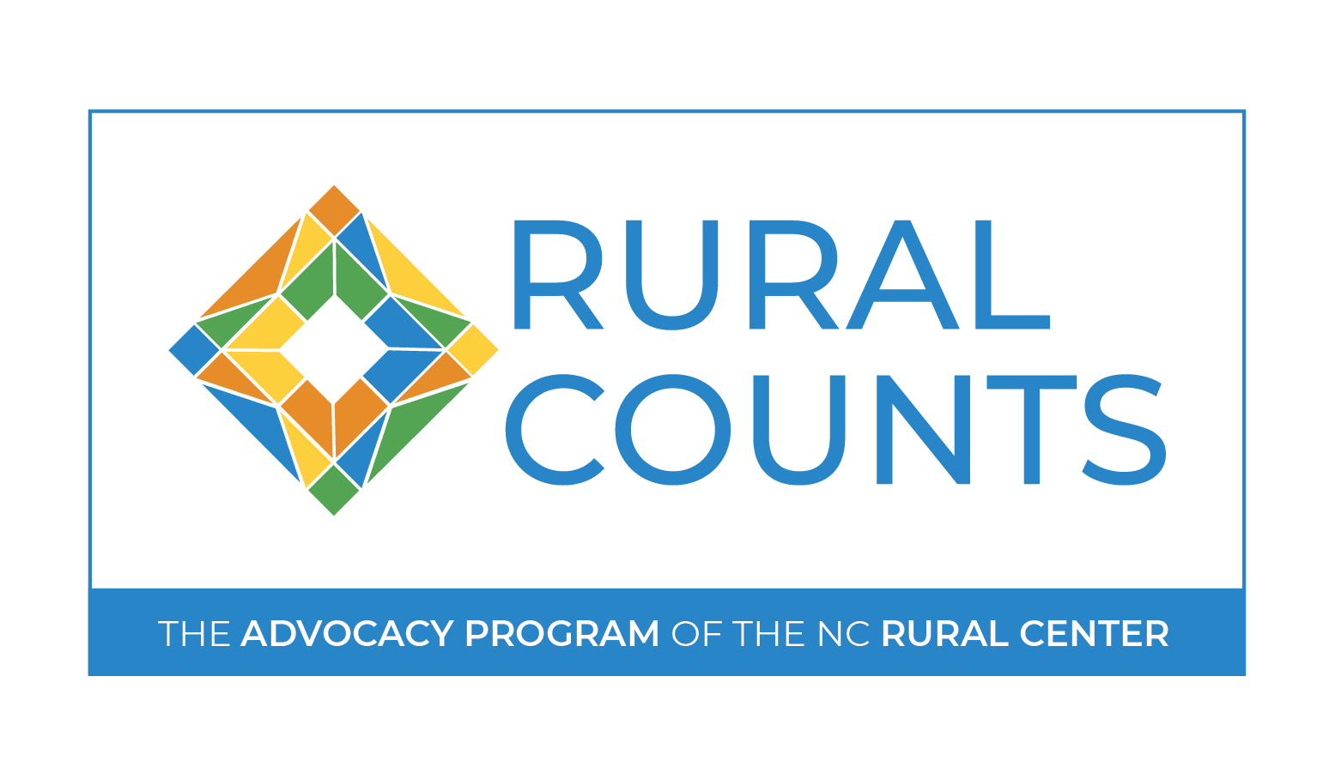
The mission of the Rural Counts advocacy program is to research, develop, and advocate for innovative, nonpartisan policy solutions to address rural North Carolina's economic development challenges and improve the quality of life for our state's rural people and places. We believe that to best advocate for rural North Carolina, we must promote sound public policy. Our positions are informed by leading-edge, unbiased research and data, and by the wisdom and expertise of the people who call rural North Carolina home.

