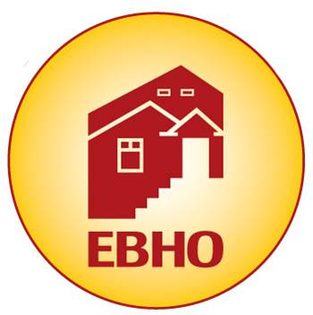
EBHO’s Affordable Housing Month Kick-Off Event, May 13th!
________________________________________________________________________________________________________________________________________________________________________
Annual Affordable Housing Month: May 9th – 17th

“Affordable Homes For All”

Thursday, May 13th, 2021
5:30 pm – 7:00 pm

Partner $ 5,000+ | Prominent listing of logo in all Affordable Housing Month promotion email blasts and on our Affordable Housing Month Webpage (with logo links to your organization) ⦁ Acknowledgement on our Facebook and Instagram pages (with tags) ⦁ Visual and named acknowledgement during our Affordable Housing Month Kickoff event ⦁ Visual acknowledgement at EBHO-hosted Affordable Housing Month Events ⦁ Logo featured on our save-the-date postcard.
Advocate $ 3,000 | Prominent listing of your logo in all Affordable Housing Month promotion email blasts and on our Affordable Housing Month Webpage (with links from the logo on our webpage to your organization) ⦁ Acknowledgement on our Facebook and Instagram pages (with tags) ⦁ Visual acknowledgement during our Affordable Housing Month Kickoff ⦁ Visual acknowledgement during EBHO-Sponsored Affordable Housing Month events.
Organizer $ 2,000 | Listing of your logo in all Affordable Housing Month promotion email blasts and on our Affordable Housing Month Webpage (with links from our webpage to your organization) ⦁ Acknowledgement on our Facebook and Instagram Pages ⦁ Visual acknowledgement during our Affordable Housing Month Kickoff event.
Ally $ 800 | Listing of your name in all Affordable Housing Month promotion emails and on our Affordable Housing Month webpage with a link to your organization from our page ⦁ Organization name listed in our visual sponsorship thank-you during the Affordable Housing Month Kickoff event.
Friend $ 500 | Listing of your name in all Affordable Housing Month promotion emails and on our Affordable Housing Month webpage with a link to your organization’s website.
Neighbor $ 300 | Listing of your name in all Affordable Housing Month Kickoff promotion emails and on our Affordable Housing Month webpage.

DEADLINE FOR SPONSOR NAME TO APPEAR ON SAVE-THE-DATE POSTCARD: Friday, March 26th, 2021

DEADLINE FOR SPONSOR NAME TO APPEAR IN PROGRAM: Friday, April 16th, 2021

YES! I will sponsor EBHO's Annual Affordable Housing Month Kick-Off!

We will sponsor EBHO's Annual Kick-Off at the following level: $__________________________________

Contact Name ________________________________________________ ______________ ________

Sponsor Name (as you wish to be listed) _____________________________________________________________________________
Address _______________ City/State/Zip _______________

Phone _________ E-mail _________________________________ ____________________________________

Please complete this form and mail with check payable to EBHO.
You can also pay online at www.EBHO.org and email this form to Kiki@ebho.org

THANK YOU FOR YOUR SUPPORT!

Your contribution is tax-deductible to the full extent of the law - tax ID# is: 94-3232405.
538 NINTH STREET, SUITE 200, OAKLAND, CA 94607 / P: 510.663.3830 / www.EBHO.org

